

<Name of Software Application>

CS 465 Project Software Design Document
Version 1.2

Table of Contents

CS 465 Project Software Design Document 1
Table of Contents 2
Document Revision History 2
Instructions 2
Executive Summary 3
Design Constraints 3
System Architecture View 3
Component Diagram 3
Sequence Diagram 4
Class Diagram 4
API Endpoints 4
The User Interface 4

Document Revision History

Version | Date | Author | Comments
1.2 | <4/19/2026> | <Seunghwan Lee> | <Finalized Software Design Document with complete System Architecture View, including component and sequence diagrams, and fully defined API endpoints.>

Instructions

Fill in all bracketed information on page one (the cover page), in the Document Revision History table, and below each header. Under each header, remove the bracketed prompt and write your own paragraph response covering the indicated information.

Executive Summary

<The Travlr Getaways web application is designed using a three-tier architecture based on the MEAN stack, which includes MongoDB, Express.js, Angular, and Node.js. This architecture separates the presentation layer, application logic, and data storage, allowing for scalability, maintainability, and efficient full-stack development using a unified JavaScript environment.

The system consists of two primary components: a customer-facing web application and an administrator single-page application (SPA). The customer-facing application enables users to browse travel destinations, search available trips by criteria such as location and price, view detailed travel packages, and access itinerary information. This interface is built using Express with Handlebars templating to dynamically render data retrieved from the backend.

The administrator SPA, developed using Angular, provides authorized users with a dynamic and responsive interface for managing application data. Administrators can create, update, and delete travel packages, manage pricing, and maintain customer-related data without requiring full page reloads. This SPA communicates with the backend through RESTful API endpoints, enabling seamless data interaction.

The backend is implemented using Node.js and Express.js, which handle routing, business logic, and API request processing. MongoDB, accessed through Mongoose, serves as the NoSQL database for storing travel packages, user data, and related information in a flexible, document-oriented format.

Security is enforced through authentication mechanisms, including login functionality and token-based authorization, ensuring that administrative features are accessible only to authorized users. Overall, the MEAN stack provides a cohesive and efficient solution that fulfills both customer-facing and administrative requirements while supporting future scalability.>

Design Constraints

<The development of the Travlr Getaways web application is guided by several design constraints that influence system architecture and implementation decisions.

A primary constraint is the requirement to use the MEAN stack, which limits the technology choices to MongoDB, Express.js, Angular, and Node.js. While this constraint enforces consistency across the application and enables full-stack JavaScript development, it restricts the use of alternative frameworks or databases that may offer different capabilities.

Another key constraint is the need to support both a public-facing web application and a secure administrator SPA within the same system. This introduces additional complexity in implementing authentication and authorization mechanisms, such as token-based security, to ensure that only authorized users can access administrative functionality and protected API endpoints.

The application must follow a database-driven architecture, where all travel-related data is stored in MongoDB and accessed through RESTful API calls. This eliminates reliance on static content and requires proper integration between the frontend, backend, and database layers. Any failure in this integration can directly impact system functionality and user experience.

Security requirements also impose constraints on development. The system must protect sensitive data, validate user input, and prevent unauthorized access. Implementing secure login processes, encrypted credentials, and protected routes increases development complexity but is essential for maintaining system integrity.

Finally, scalability and maintainability are critical considerations. The system must be capable of handling increased user activity and expanding data over time. This requires a modular design, clear separation of concerns, and well-structured code, which may increase initial development effort but ensures long-term flexibility and ease of maintenance.>

System Architecture View

Component Diagram

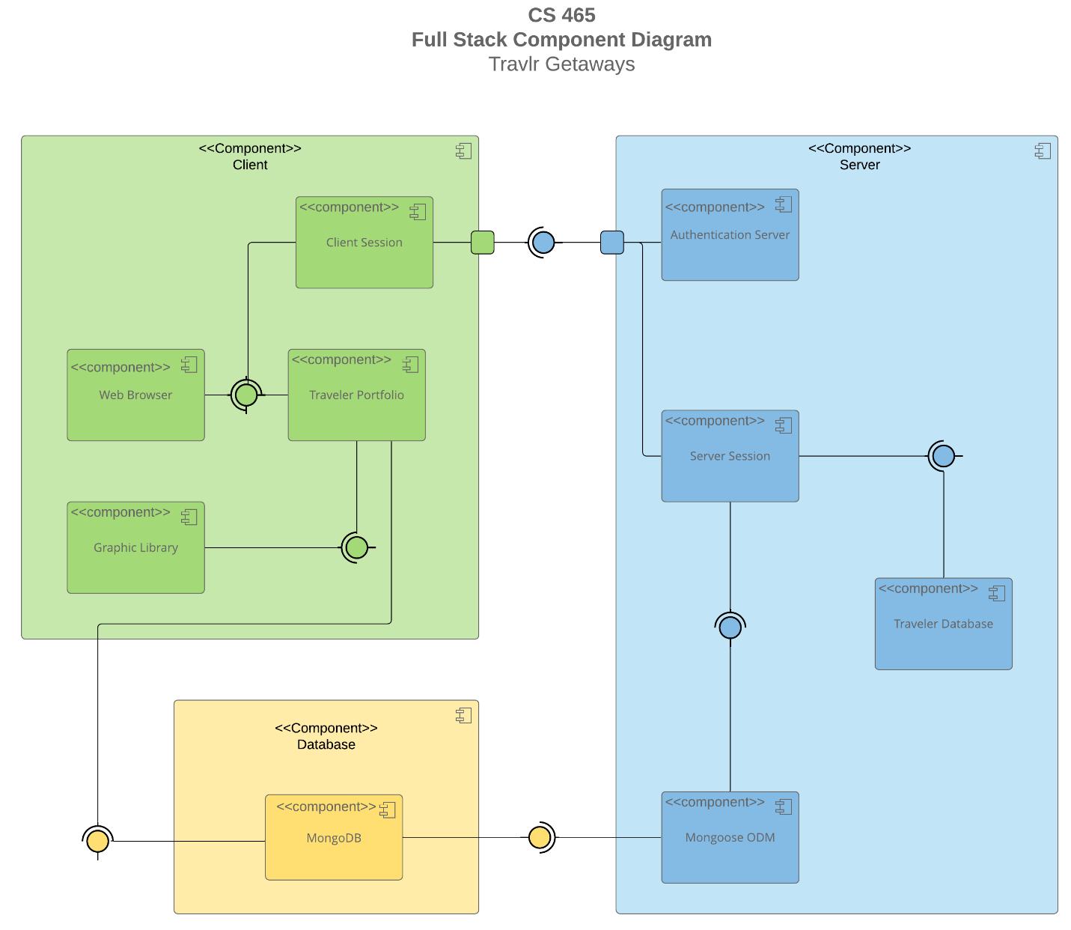

A text version of the component diagram is available: CS 465 Full Stack Component Diagram Text Version.

<The component diagram represents the architecture of the Travlr Getaways full stack web application, organized into three primary layers: the client layer, the server layer, and the database layer. This structure follows the MEAN stack architecture and supports both the customer-facing application and the administrator single-page application (SPA).

On the client side, the web browser serves as the primary interface through which users interact with the system. This layer includes components such as the client session and the traveler portfolio. The client session manages user interactions, including HTTP requests and authentication tokens, while the traveler portfolio represents the dynamic presentation of travel data within the user interface. A graphic library supports rendering and styling of visual elements. The client layer includes both the Express-rendered views (Handlebars templates) for the customer-facing site and the Angular SPA for administrative functionality.

The client communicates with the server through HTTP and RESTful API requests. On the server side, the application is built using Node.js and Express.js, which manage routing, middleware, and business logic. The authentication server component is responsible for validating user credentials and issuing secure tokens for authorized access to protected routes, particularly within the administrator SPA. The server session component processes incoming requests, applies application logic, and coordinates responses between the client and the database.

The server interacts with the database layer through the Mongoose Object Data Modeling (ODM) component. Mongoose defines schemas and models that structure the application’s data and provide an interface for querying and updating the database. The underlying database is MongoDB, which stores travel-related data such as trip packages, pricing, and user information in a flexible, document-oriented format.

The relationships between these components follow a structured data flow. Client requests are sent to the Express server via defined routes and API endpoints. The server processes these requests, interacts with MongoDB through Mongoose models, and returns JSON responses to the client. The client then renders this data dynamically, either through Handlebars templates or within the Angular SPA interface.

Overall, the key components—client interface, Express server, authentication system, and MongoDB database—work together to form a modular and scalable architecture. Each layer has a clearly defined responsibility, ensuring separation of concerns, efficient data handling, and secure access control throughout the application.>

Sequence Diagram

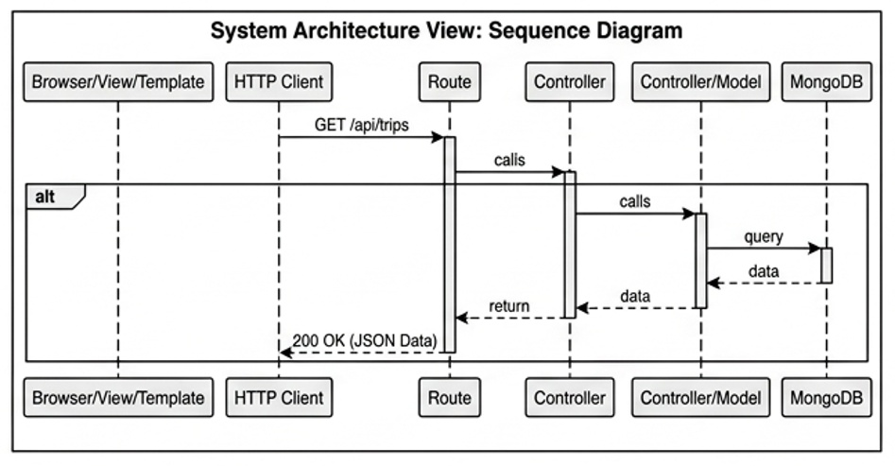

< The sequence diagram illustrates the flow of logic for retrieving travel data within the Travlr Getaways application, highlighting the interaction between the client, server, and database layers in a MEAN stack architecture.

The process begins at the Browser/View/Template layer, where a user action—such as selecting the option to view available trips—initiates a request. The HTTP client then sends an asynchronous GET request to the backend API endpoint (/api/trips). This request is received by the Express routing layer, which matches the request to the appropriate route handler and forwards it to the corresponding controller.

The controller processes the request and invokes the Mongoose model, which defines the schema and structure for the travel data. The model interacts with MongoDB by executing a query to retrieve the requested trip documents. MongoDB returns the data to the model, which passes it back to the controller.

The controller then formats the retrieved data into JSON and sends a response with a 200 OK status back to the client through the Express server. The HTTP client receives this response and updates the Browser/View/Template dynamically, allowing the trip information to be displayed without requiring a full page reload.

In addition to data retrieval, this sequence structure supports secure operations by allowing authentication middleware to intercept requests and validate tokens before granting access to protected endpoints, such as those used by the administrator SPA.

Overall, the diagram demonstrates a clear and structured flow of data through the application layers, including client interaction, API routing, server-side processing, database querying, and dynamic UI updates.>

Class Diagram
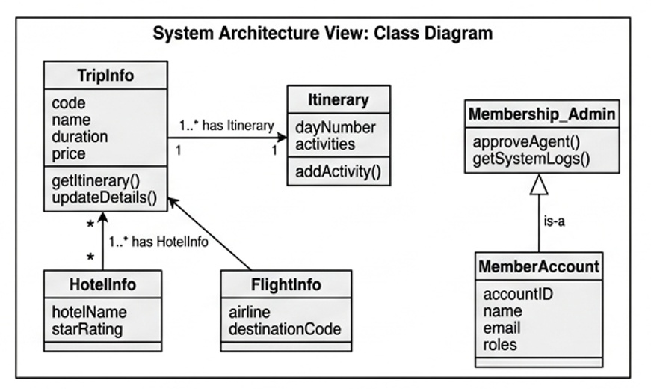

< The class diagram illustrates the core data structures and object relationships within the Travlr Getaways application, representing how travel-related data is organized and managed in the system. These classes align with the Mongoose schemas used in the MongoDB database, supporting a flexible, document-oriented data model.

The TripInfo class serves as the central entity, containing key attributes such as code, name, duration, and price. It maintains a one-to-one relationship with the Itinerary class, which stores detailed day-by-day activity information for each trip. Additionally, TripInfo has one-to-many relationships with both HotelInfo and FlightInfo, allowing each trip to include multiple hotel options and flight details. This modular structure improves data organization and supports scalable travel package configurations.

Each supporting class encapsulates specific aspects of the travel experience. The HotelInfo class includes attributes such as hotel name and star rating, while the FlightInfo class stores airline and destination information. The Itinerary class provides methods for managing daily activities, enabling structured and dynamic trip planning.

For administrative and security functionality, the system implements an inheritance relationship between MemberAccount and Membership_Admin. The MemberAccount class represents general users and stores account-related data such as account ID, name, email, and roles. The Membership_Admin class extends this base functionality by adding administrative capabilities, such as approving agents and accessing system logs. This role-based design supports secure access control within the administrator SPA.

Overall, the class diagram reflects a modular and extensible design that aligns with the application’s backend implementation using Mongoose models. It demonstrates clear relationships between entities, supports separation of concerns, and enables efficient data management within the MongoDB database.>

API Endpoints

<Exposing RESTful endpoints is a design approach to enable an application to participate in a larger ecosystem. Document each endpoint in the table below, including the HTTP method, purpose, URL, and notes.>

Method | Purpose | URL | Notes
GET | Retrieve all trips | /api/trips | Used by the public website to display the travel catalog.
GET | Retrieve specific trip | /api/trips/:tripCode | Fetches full details for a single trip based on its unique code.
POST | Create a new trip | /api/trips | Restricted to authorized administrators; requires JWT authentication.
POST | Register user | /api/register | Creates a new user account
PUT | Update a trip | /api/trips/:tripCode | Allows administrators to modify existing trip details in the SPA.
DELETE | Remove a trip | /api/trips/:tripCode | Permanent removal of a trip record; restricted to admin access.

The User Interface

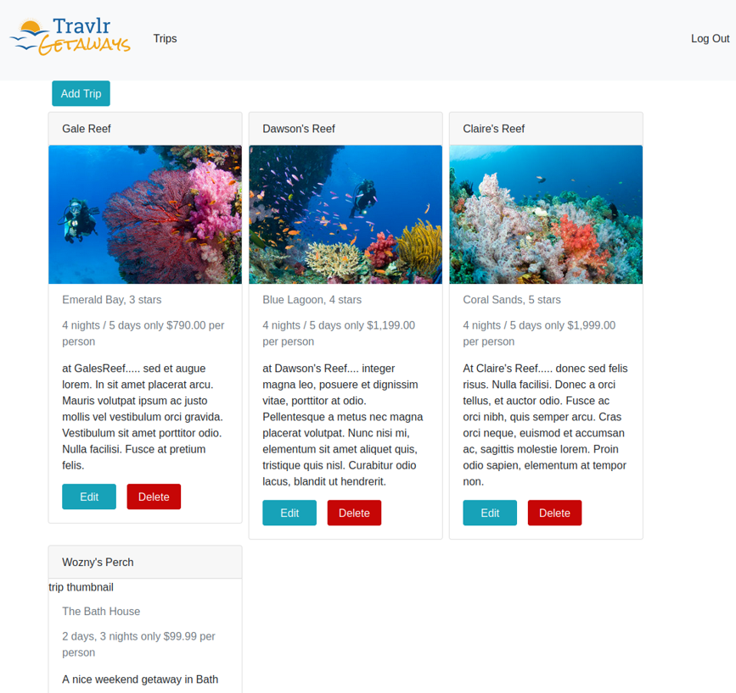
The User Interface - Unique Trip Addition
The provided screenshot illustrates the Admin Dashboard of the Travlr Getaways Single Page Application (SPA). This view confirms that the frontend successfully communicates with the backend API to manage and display travel data.

Key Technical Observations:
Dynamic Data Rendering: The entry for "Wozny’s Perch" serves as the unique trip added to the system. The successful rendering of its specific details—such as the $99.99 price point, the "Bath House" location, and the specific trip duration—proves that the Angular component is correctly iterating through a collection of objects retrieved from the database.

Asynchronous Integration: This interface demonstrates a successful HTTP GET request facilitated by the TripDataService. The SPA does not rely on hardcoded HTML for these cards; instead, it fetches a JSON payload from the Express API and uses the *ngFor structural directive to build the UI dynamically.

State-Driven UI: The presence of the "Add Trip", "Edit", and "Delete" buttons highlights the administrative functionality of the SPA. These elements are mapped to specific routes and controller functions, ensuring that the user can interact with the underlying MongoDB data without requiring a full page refresh.

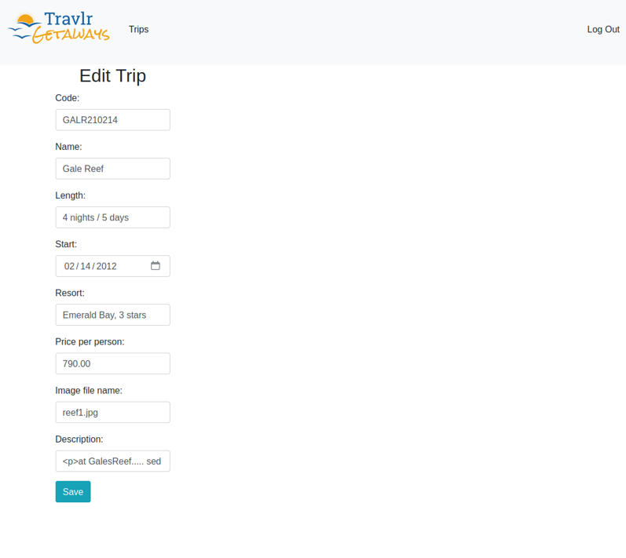
The Edit Screen
The screenshot captures the Edit Trip component, which is a core feature of the administrative SPA. This interface allows the user to modify existing record details before they are sent back to the server.

Key Technical Observations:
Reactive Form Pre-population: The form is successfully pre-populated with data for "Gale Reef" (Code: GALR210214). This confirms that when the "Edit" button was clicked on the dashboard, the Angular router passed a unique parameter (the trip code) to this component. The component then performed an immediate GET request to fetch that specific record’s details.

Two-Way Data Binding: This screen utilizes Angular’s two-way data binding (typically via [(ngModel)] or Reactive Forms). This ensures that any change made by the user in these input fields is instantly updated in the component's underlying TypeScript data model.

Data Integrity: By displaying the specific fields—such as the price ($790.00), the image filename (reef1.jpg), and the HTML-formatted description—the SPA ensures the administrator can see exactly what is currently in the database before making edits. This reduces errors compared to a standard web interaction where a user might have to remember the previous values.

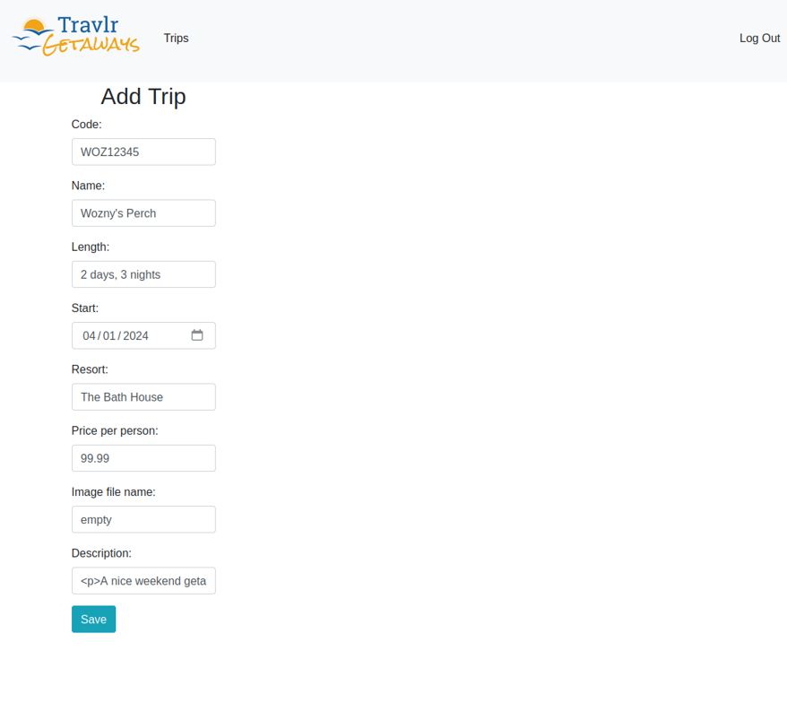
The Update/Add Screen (Data Entry)
The screenshot displays the Add Trip interface, where the user inputs the specific details for a new travel record. This represents the "Create" operation in the application's CRUD (Create, Read, Update, Delete) cycle.

Key Technical Observations:
Data Capture and Mapping: The form fields correspond exactly to the attributes defined in the Mongoose Schema on the backend. By entering values like the code WOZ12345 and the price 99.99, the Angular SPA prepares a structured data object to be transmitted across the network.

API Communication (HTTP POST): When the "Save" button is clicked, the TripDataService executes an asynchronous HTTP POST request. This sends the form data as a JSON payload to the Express backend. This interaction is invisible to the user, showcasing the SPA's ability to update the database without a page reload or "white-flash" transition.

Input Validation: This screen serves as the first line of defense for data integrity. The SPA architecture allows for real-time validation (e.g., ensuring the price is a number or the code is unique) before the data ever touches the API, improving the overall reliability of the system.

<The Travlr Getaways application uses two distinct frontend structures: an Express-based web application for the customer-facing site and an Angular-based single-page application (SPA) for administrative functionality. While both interact with the same backend API, their structures and behaviors differ significantly.

The Express application follows a Model-View-Controller (MVC) architecture, where routes handle incoming requests, controllers process business logic, and Handlebars (HBS) templates render dynamic content on the server side. Each user interaction typically results in a new HTTP request and a full page reload, making it suitable for simpler, content-driven user experiences such as browsing travel packages.

In contrast, the Angular application is structured as a component-based SPA. It consists of modules, components, and services. Components manage specific parts of the user interface, such as trip lists and edit forms, while services handle communication with the backend API using HTTP requests. Angular routing enables navigation between views without reloading the page, creating a seamless and responsive user experience.

The SPA provides richer functionality compared to the Express application. Administrators can create, edit, and update travel packages dynamically, with changes reflected immediately in the interface. Features such as form validation, two-way data binding, and asynchronous API calls allow for efficient data handling and improved usability. This eliminates the need for full page refreshes and enables a more interactive and fluid workflow.

To ensure the SPA functions correctly with the backend API, testing was performed using both manual interaction and API validation. GET requests were tested by retrieving trip data from the /api/trips endpoint and verifying that the data was correctly displayed within Angular components. PUT requests were tested through the edit and update forms in the SPA, where modifications to trip data were submitted to the API and persisted in the MongoDB database. The results were verified by re-fetching the updated data and confirming that changes were accurately reflected in the user interface.

Overall, the Angular SPA enhances the administrative capabilities of the application by providing a dynamic and efficient interface, while the Express application supports a simpler, user-friendly experience for customers. Together, they demonstrate the flexibility and power of a full stack MEAN architecture.>

